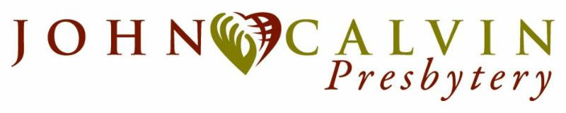
PEACEMAKING and GLOBAL WITNESS GRANT APPLICATION

MISSION & NURTURE COMMITTEE

NAME OF CHURCH AND GROUP APPLYING:

ADDRESS:

CONTACT PERSON:

PHONE NUMBER:

EMAIL ADDRESS:

AMOUNT REQUESTED:

DESCRIPTION OF REQUEST TO INCLUDE THE FOLLOWING AND SIGNED BY CONTACT PERSON, CLERK OF SESSION AND PASTOR.

The request can be attached to this cover sheet and limited to one page

1. Specifics of event(s), what, who, where

2. Who will be involved—church member, community, leaders

3. How will this event fulfill the mission of Peacemaking? (remember this is a broad mission)

4. Give a budget projection for amount requested and additional monies used.

After the event, be prepared to submit a written report to the moderator of the Mission and Nurture Committee of John Calvin Presbytery, accounting for dollars spent, effectiveness of the event, and how the event fulfilled the Peacemaking mission. This report is due one month after the event takes place or has started.

PEACEMAKING and GLOBAL WITNESS GRANT
MISSION AND NURTURE COMMITTEE

The Peacemaking Grant offered by the Mission and Nurture Committee of John Calvin Presbytery provides funding to churches or organizations within churches that have an idea for a project or event that promotes the mission of peacemaking. The peacemaking mission involves reaching out to our Presbytery and/or local community to heighten awareness of promoting peace and justice.

This is an opportunity to “think outside the box” of ways to reach individuals and provide ways for them to become involved in attaining the goals of social justice and peace.

Ideas of projects that might qualify for the Peacemaking Grant:

1. Fund a youth group to travel to various churches in the Presbytery to present an “anti-bullying” program.

2. Provide start up funds for a church to operate a small Fair Trade Store

3. Provide funds for a church to hold a “Peacemaking Conference” featuring guest speakers, hands on activities, and worship

4. Provide funding to offset the cost of travel to a seminar on conflict in the Middle East sponsored by the Presbyterian Office at the United Nations in New York

5. Provide “seed money” for an outreach program that provides meals at a homeless shelter or to a church to start a food pantry or lunch program.

The ideas are endless. The Peacemaking Grant is to help you realize your goal of creating a program/project that will educate, inform and motivate others to become involved in Peacemaking efforts. Further ideas can be found at www.pcusa.org/peacemaking

Complete the application and send by email to:
Recording Clerk, Gail Wilson: gwilson@jcpresbytery.com
Cc: Pastoral Presbytery, Malinda Spencer: mspencer@jcpresbytery.com

The deadline is April 15 and the Grant will be presented at the May Presbytery meeting. It is important to note that the grant not to be used for salaries or capital improvements.

The Mission and Nurture Committee is excited about this new opportunity for sharing the Peace of Christ. Take this time to be imaginative, creative and positive in ways your church can promote the mission of peacemaking.

Yours in Christ,
Mission & Nurture Committee

