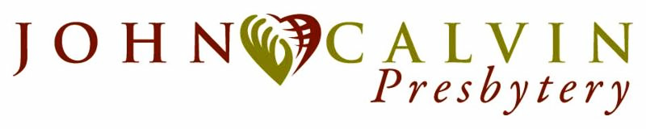

CREATIVE MINISTRIES GRANT

Relevant information---please read before completing application:

The amount available for 2021 Creative Ministry Grants will be up to $ 11,187.00.

Consideration will be given that the available money may be shared through the three geographical regions of the John Calvin Presbytery. No grant application should exceed the total amount available.

This will be a one-year grant from Creative Ministries and the grant application should represent a creative, non-budgeted mission proposal from your church.

The Creative Ministries grant is open to all churches—small and large - and we encourage congregations to work in partnership with other congregations in their vicinity. The application should be accompanied by a copy of the minutes of the session where the mission project was approved by the Session and signed by the clerk. A sample application is on the Presbytery website. Should you have further questions then please call the Presbytery ofﬁce.

Time-line: Application should be received by June 15, 2021 and the grants will be made in August. Within two months of the completion of the mission program, a detailed report shall be submitted detailing the numbers of individuals involved (church congregation(s) and community), total monies spent, and a subjective evaluation of the mission project.

APPLICATION:
Name of Church:

Number of Members: Average Worship Attendance

Mailing Address:

Contact Person:

Phone number:

Cell number:

E-mail:

Amount requested:

Attach a narrative of said proposal that shall include the following information: (Feel free to answer on separate pages)

1. Describe your mission proposal.

2. Detail the number of members of your congregation involved, the number of members from other
congregations involved and the number of community folks who will also be involved.

3. Provide a budget of the proposal (and it may be a narrative budget).

4. Indicate the time frame for the project as well as the number of persons who will be impacted by the
mission project (within the congregation(s) and within your community).

By email send your completed grant application to:

Recording Clerk, Gail Wilson: gwilson@jcpresbytery.com
cc: Pastoral Presbyter, Malinda Spencer: mspencer@jcpresbytery.com

