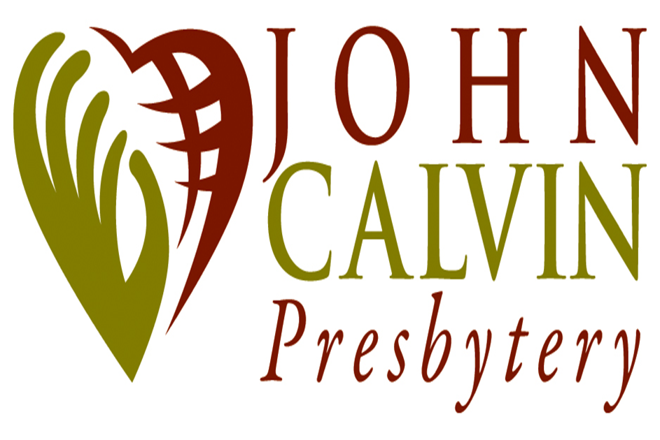
For Office Use Only:
Confirmation # ______________________
Date paid ___________________________
Account Number ______________________
Posted ______________________________ Acct. # ____
Date paid _________
Acct. # ____
P. O. Box 787, Shell Knob, MO 65747

EXPENSE VOUCHER 2020

The following is an accurate report of the expenses incurred while on Presbytery business, and /or as authorized by Presbytery, its Council or Committee action. Vouchers / requests over $2,500 MUST receive a second signature by appropriate staff person prior to request being made.

Date:

Make check payable to:

Address, Street or P.O. Box #

City, State and Zip Code

Charge to: ( Committee or Budget Line Item or Designated Account )

Specific Activity:

Meeting at:

Detailed Accountability:
1. Mileage: round trip at $ .20 per mile regardless of number of passengers. For a variety of
stewardship reasons, persons are expected to carpool whenever possible.
Total number of miles @ .20 cents per mile $

2. Miscellaneous ( specificity required ) $

Less amount donated to the church ( i.e. John Calvin Presbytery ) $

TOTAL: $

Receipts must be submitted for all expense items over $20.
Note: Accepting reimbursement could affect your adjusted gross income and income taxes. Please consult with your tax advisor.

Signature of Chairperson of Presbytery Committee or Designee or Acting GP/Pastoral Presbyter or Stated Clerk

APPROVED POSITION

APPROVED POSITION

